**AWS-Quick-sight**

**Spotify data set**

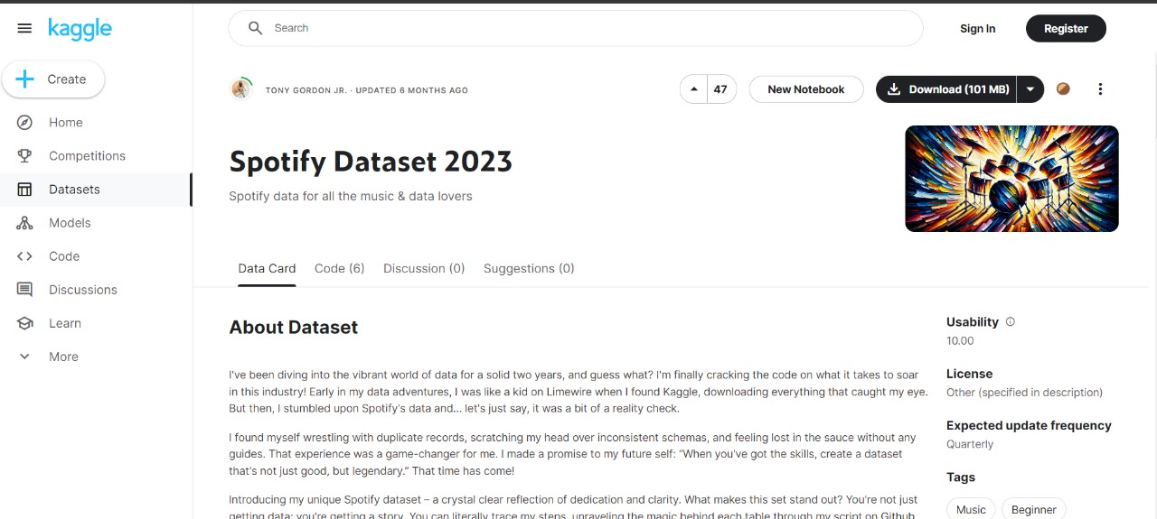

AWS Console

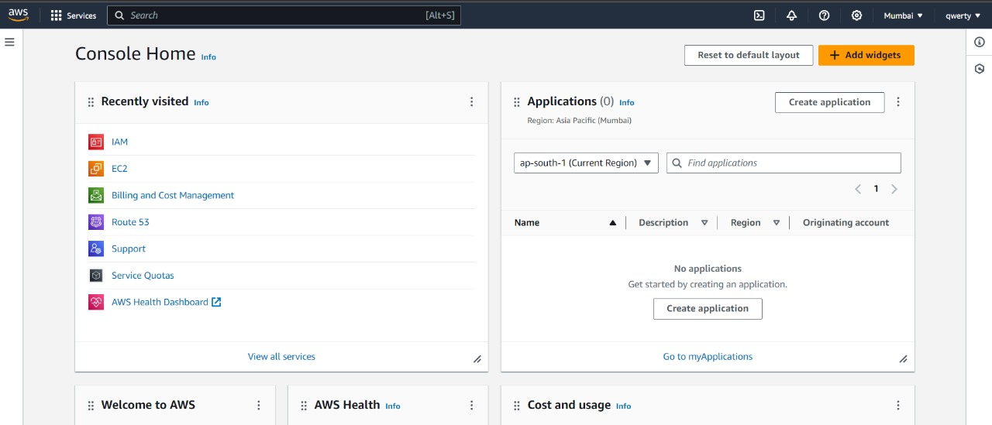

Policies For IAM user

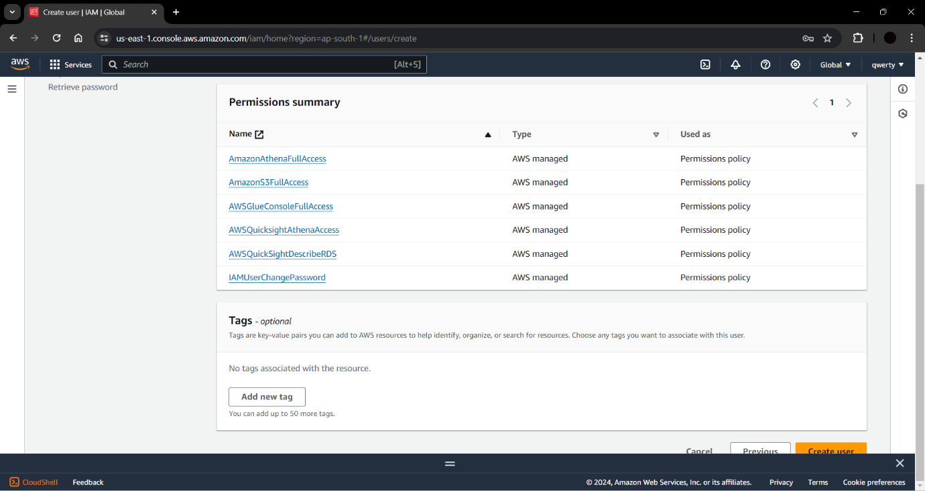

Creating S3 Bucket and uploading Spotify files in staging folder and also created Datawarehouse folder(destination).

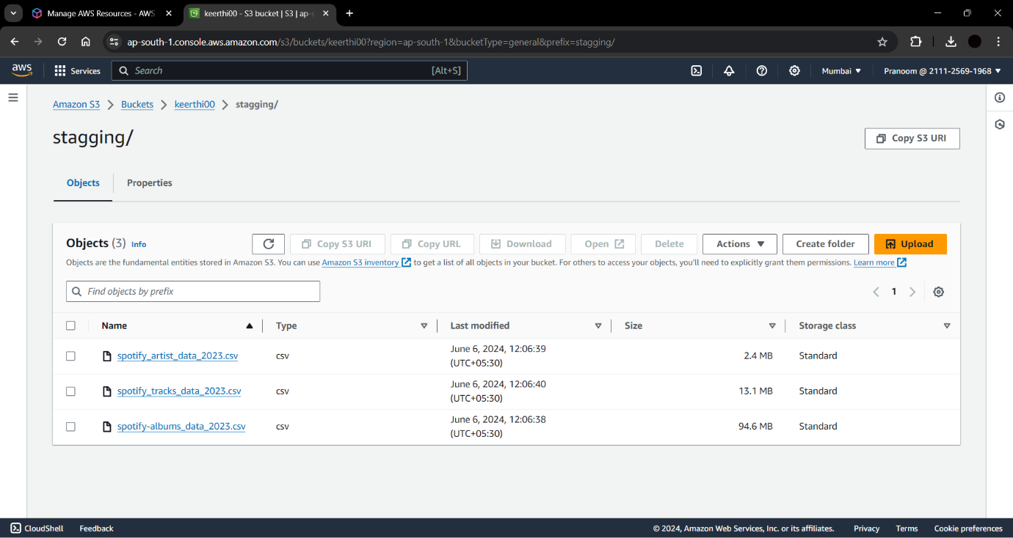

After that Pipelined with join operation into destination bucket and created IAM glue policy.

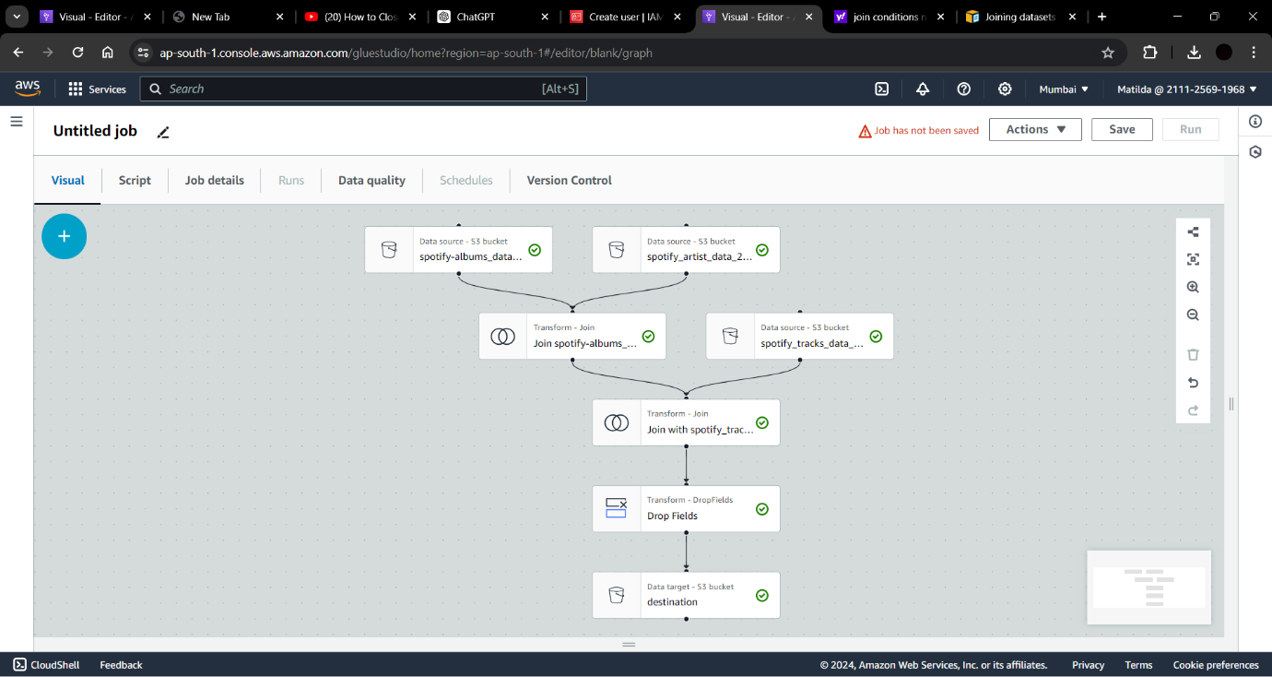

After running the Spotify project the objects are stored in Data ware house bucket.

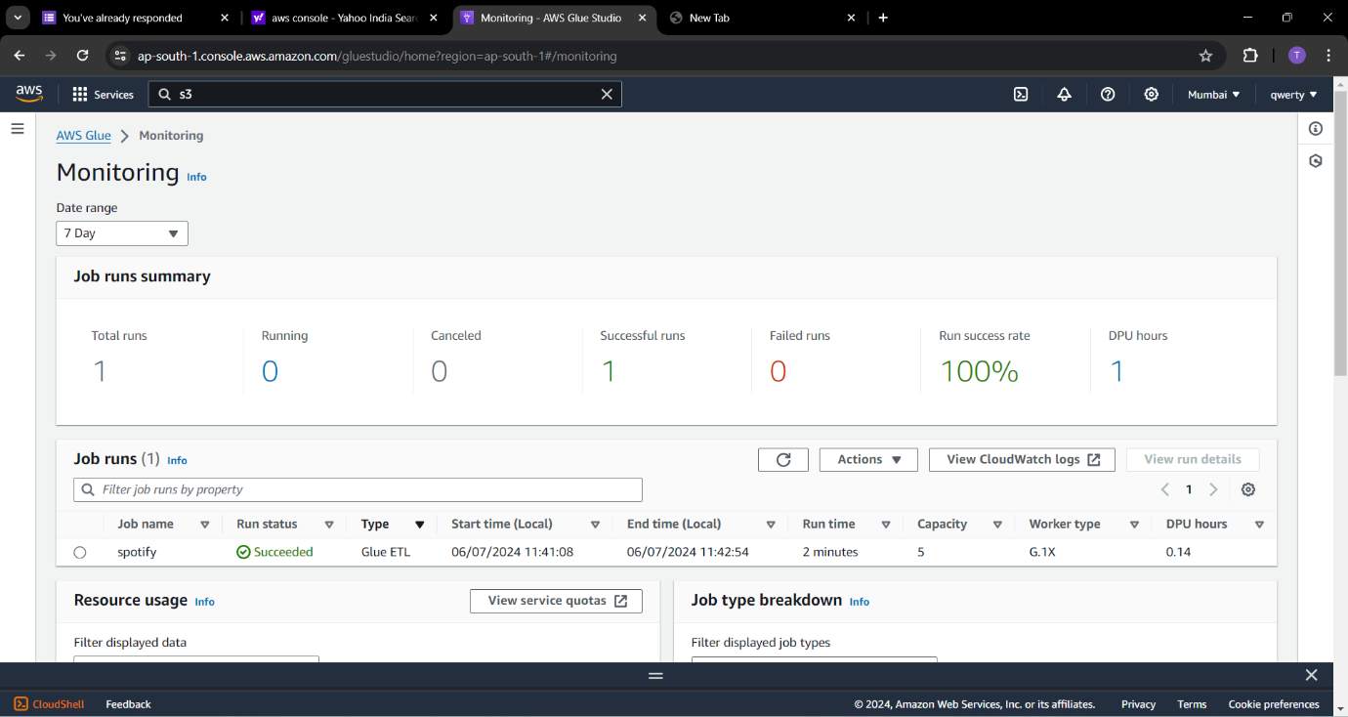

After that crawler object is created.

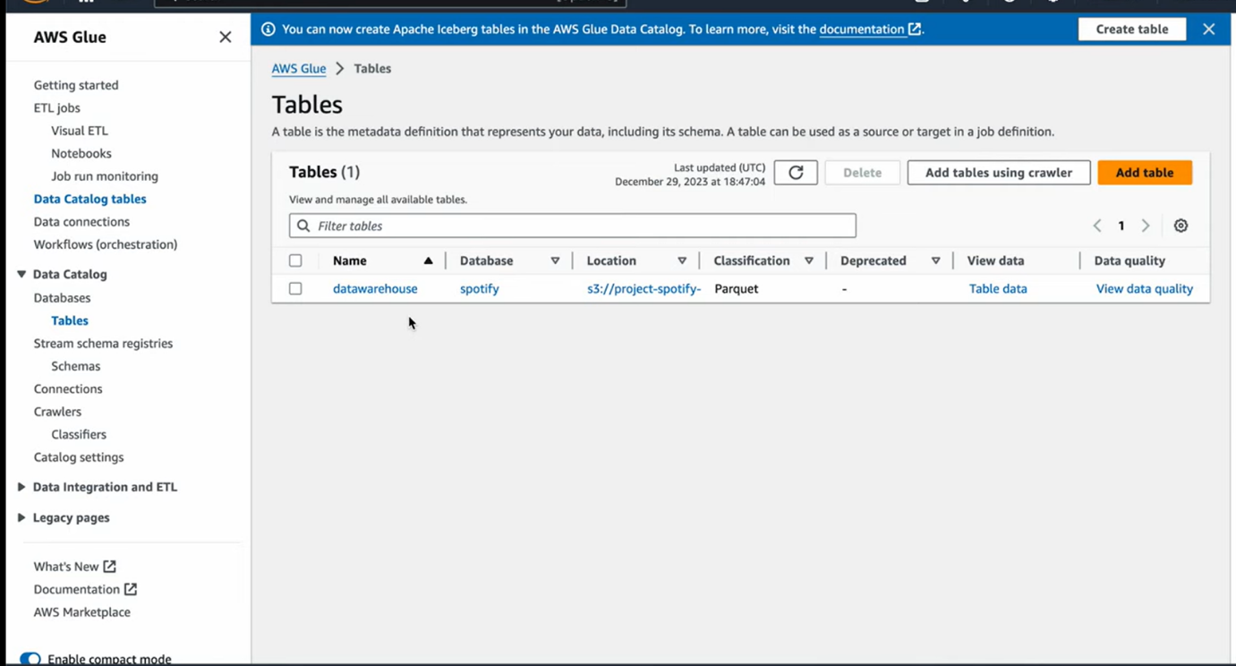

At last Athena was created to display database in Quick Sight were the output log cat be displayed as analytics or dashboards.

s

